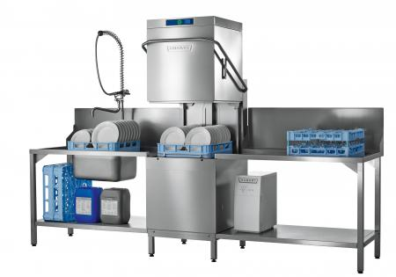

BASIC MODEL
Hood-type dishwasher for straight through or corner operation
- Nominal capacity up to 60 racks/h or 1,080 plates/h or 2,160 glasses/h
- 3 automatic cycles: short, standard, intensive
- Ready to install - completely equipped: fill / drain hose, electrical cable, detergent dispenser, rinse aid dispenser, rinse pump, drain pump, back-flow prevente
- 1 plate rack P-18-12
- 1 universal flat rack B-00-07
- 1 plastic cutlery rack CB8

PRODUCT ADVANTAGES
- VISIOTRONIC control: single button control with remaining time indicator together with text and graphic display
- Exhaust energy storage: the fully enclosed 4-sided hood keeps steam and energy inside the system: energy saving up to 3 kW/h, less humidity in the kitchen area and better hygienic conditions
- CLIP-IN wash and rinse arms: wash and rinse arms can be removed with one hand and without any tools
- EASY-CLEAN concept: blue markings in the machine help the operator to identify the components which require cleaning

TECHNICAL DATA
Flexible drain hose 2,000 mm | 20mm inner / 25mm outer diam.
Fresh water connection:  pressure hose 2,000 mm  flow pressure  necesassary waterflow | R 3/4" inside  0.5 - 10 bar max 60°C  softener models:  0.8 - 10 bar  5 l/min
Power cord | 2,500 mm
Hoses for detergent and rinse agent | 2,000 mm each
Cycle times ¹⁾ | 60 sec.  90 sec.  180 sec.
Water consumption | 2.5 l / rack
Tank capacity | 23 l
Tank heating | 2.5 kW interlocked
Power supply | 400 / 50 / 3 / N
Booster loading | 6.2 kW
Total loading | 7.1 kW / 3 x 16 A
Pump capacity | 0.7 kW / 350 l/min
Loading height | 440 mm
Noise level | 66 dB(A)
Weight gross / net | 121 / 101 kg
¹⁾ To reach set rinse temperatures even with cold water connection, the actual cycle-times extend accordingly.

